**Apartment Management system version 1.0**

There are two type of users involving in this system Apartment Owner and Apartment Manager.

**Product backlog**

**Stories**

**As A User (A)**

1. I should be able to insert CRUD on monthly payments
2. I should be able to filter results [pending approvals/due amounts]

**As A Manager (B)**

1. I should be able to see Pending Approvals/Due Payment Members
2. I should be able to approve reject the bills.
3. Register a user

**Respective UI**

**A).User**

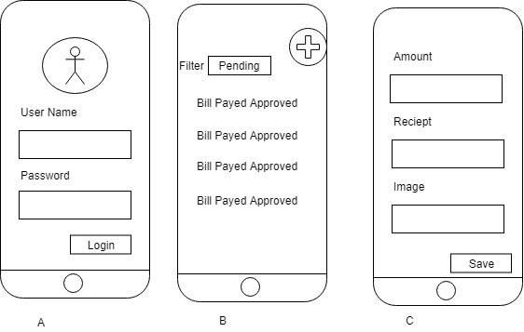

Upon Adding goes to (C)

**B).Manager**

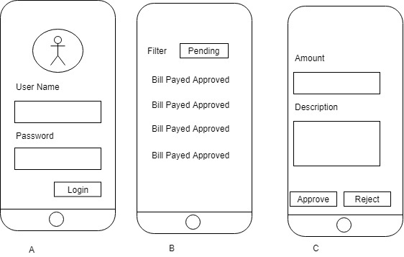

Upon clicking on list goes to (C)